**Opening a Food Outlet in Harare, Zimbabwe**

**Leo Dzingirai**

**IBM Applied Data Science Capstone Project**

## Introduction

Harare has quite a few number of restaurants which includes Chinese, Indian, Western and Traditional. The restaurant business provides a good business opportunity considering that Harare is home to approximately 1.5 million people. Opening a new restaurant requires serious consideration and there are a lot of factors to consider, which might be very complicated sometimes. Particularly, the location of the place is one of the most important decisions that will determine the success of the business.

## Business Problem

The objective of this capstone project is to analyze and select the best neighborhood in the city of Harare to open a new food restaurant. Using data science methodology and data collected through the Foursquare API, this project aims to provide solutions to answer the business question of what would be the best neighborhood to open a restaurant in Harare

## Target Audience of this project

This project is particularly useful to investors and entrepreneurs looking to open or invest in new food restaurant places in Harare. These stakeholders have a vested interest in responding to market demand by making data driven decisions. This project explores some of data insights with respect to location

## Data Description

This section describes the data sourced for this project. The following data is required;

* List of Suburbs/ Neighborhoods in Harare.
* Latitude and longitude coordinates of those suburbs.
* Venue data, particularly data related to food outlets places, nearby universities, schools and offices.

Neighborhoods data will be obtained as a csv file with a list of names of neighborhoods in Harare. I could not scrap the data from the internet because there is no available complete information data of Harare neighborhoods. Venues will be retrieved using Foursquare API. The first 5 row of the neighborhoods dataset can be visualized as follows:

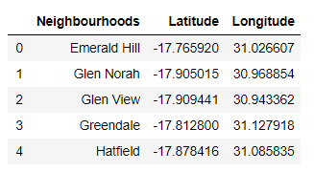

## Methodology

Geographical coordinates of the neighborhoods i.e. Longitudes and Latitudes will be obtained using Open Street Map API. Foursquare API will be used to get the venue data for those all the neighborhoods. Foursquare API will provide many categories of the venue data. We are particularly interested in the restaurant places, universities, schools and offices categories in order to help us to solve the business problem put forward. This is a project that will make use of many data science skills i.e. working with API, data wrangling, and map visualization. The best location will be selected based on the weights give to each category.

## Results

### Foursquare venue locations of nearby Restaurants.

After making API calls to Foursquare and passing the geographical coordinates of the neighborhoods, we obtain the venues data i.e. all nearby food outlets, as a data frame. A map of the venues that are a within 1000meter radius of the neighborhoods is shown below:

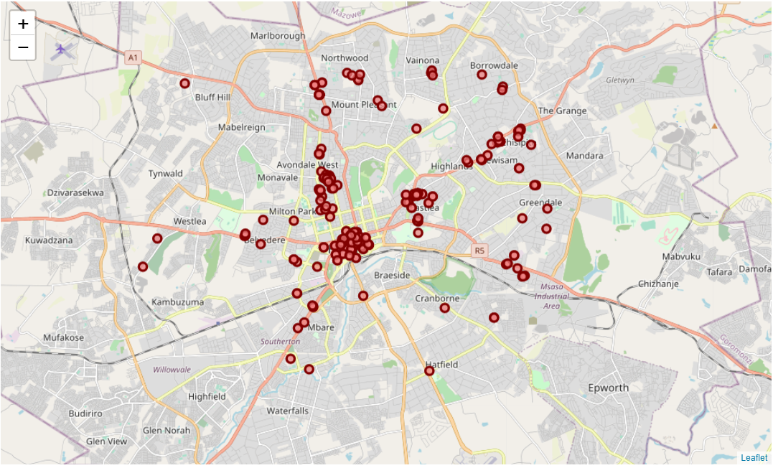

A total of 278 outlets are within a 1000m radius of the neighborhoods, with most of the venues concentrated in the CBD. The southern part of Harare has very few restaurants.

### Foursquare venue locations of nearby schools

We are also concerned about the availability of customers where we need to set up the restaurant. We can consider school children as potential customers and we therefore need to position the restaurant closer to the schools. Data for schools within 500meters of the neighborhoods is shown below;

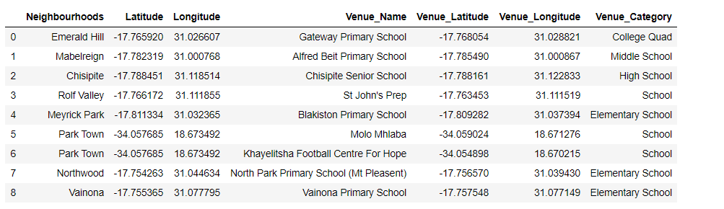

### Foursquare venue locations of nearby universities

University students are also a possible market for a food outlet. The resulting data and plot are shown below

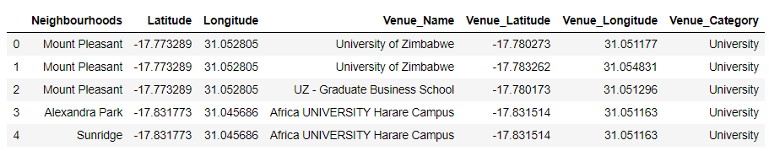

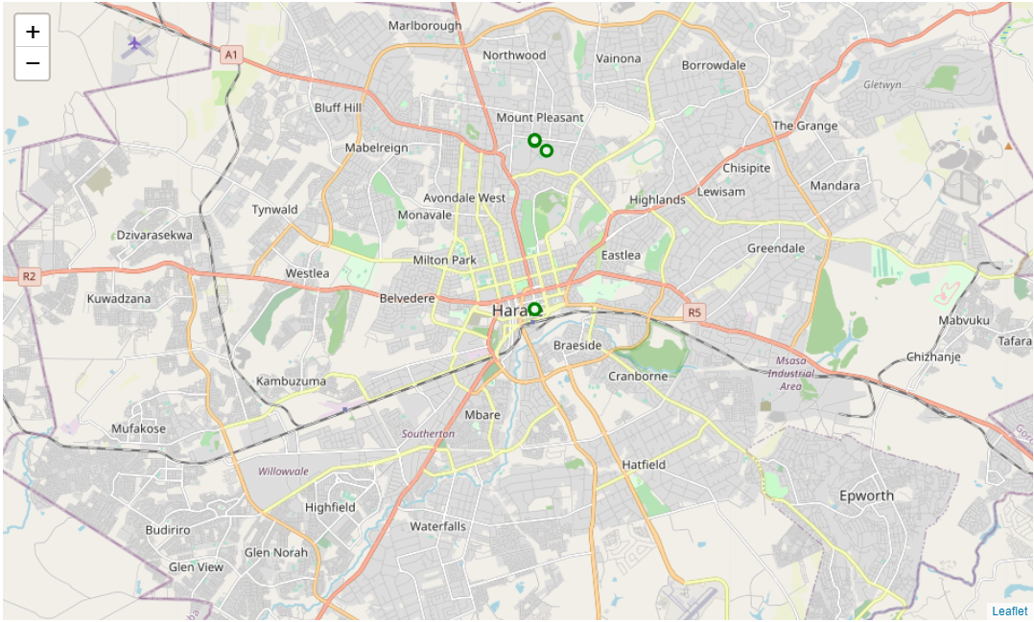

It can be seen that there are only 3 university venues within 1000m of either neighborhood in Harare, with mount pleasant being the most active neighborhood where the University of Zimbabwe is situated.

### Foursquare venue locations of nearby business offices

Another possible group of customers are the business people. We also plotted the nearby office spaces within a 500meter radius and the results are as follows;

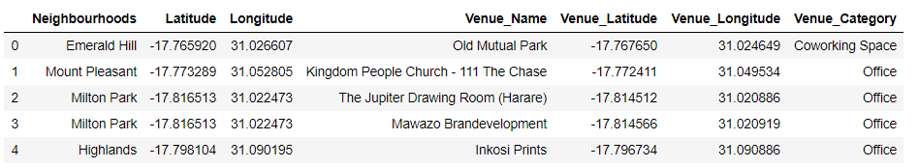

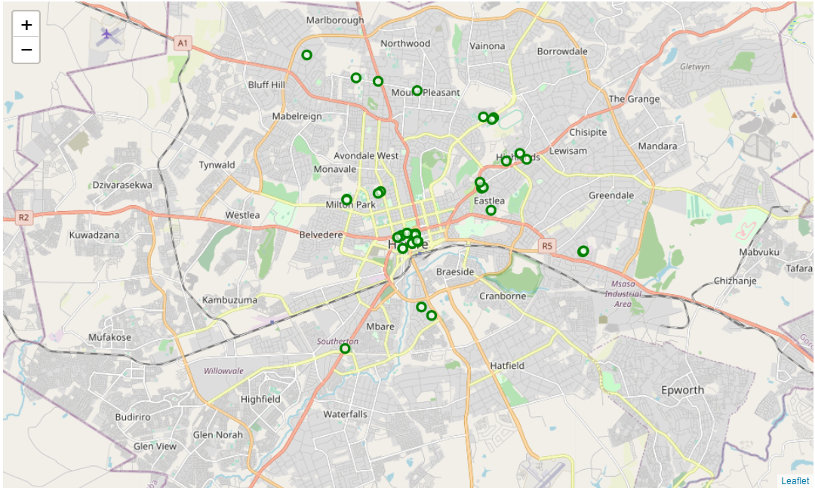

Again many office areas are located in the CBD. Few office areas in the southern part of Harare.

We can consolidate all the above information into one data frame as shown below;

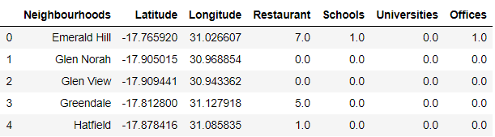

Finally, we assign weights to each category so that we can be able to determine the optimal location for setting up a new food outlet. For restaurant, we assign a negative weight because we don’t want the new outlet to be very closer to existing outlets. The weighted results are visualized as below;

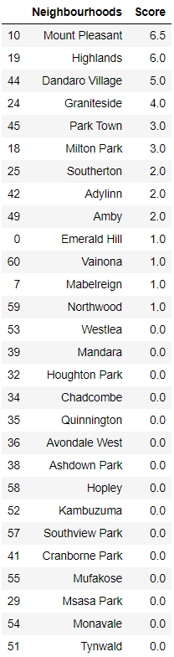

Therefore, we can conclude that the best suburb to set up a new food outlet, based on the factors outlined earlier, is Mount Pleasant with a score of 6.5, followed by Highlands with 6.0

## Conclusion

In this paper, we analyzed geographical data for the city of Harare and selected the best neighborhood in the city to open a new food restaurant. We considered factors such as proximity to other restaurants, schools, universities and office areas. From the results, it can be seen that the best location for setting up a new foot outlet is the northern part of Harare, particularly Mount Pleasant. However, given the limited time, we could not experiment with other factors and therefore it is recommended that further analysis can be done considering many factors such as proximity to road and social gatherings.

**References**

<https://developer.foursquare.com/>

[https://www.openstreetmap.org/#map=7/-16.643/29.597](https://www.openstreetmap.org/%23map=7/-16.643/29.597)